Tutorial 3
Task2: Experiment with Different Architectures
Modify the neural network architecture to see how it affects model performance.
Table 1
Architecture | Performance after 10 epochs
- Original Architecture  ----------------------------------------------------------------  Layer (type) Output Shape Param #  ================================================================  Flatten-1 [-1, 784] 0  Linear-2 [-1, 128] 100,480  ReLU-3 [-1, 128] 0  Linear-4 [-1, 64] 8,256  ReLU-5 [-1, 64] 0  Linear-6 [-1, 10] 650  =============================================================== | Train Acc: 1.00, Val Acc: 0.98  Test Acc: 0.978
- With more layers  ----------------------------------------------------------------  Layer (type) Output Shape Param #  ================================================================  Flatten-1 [-1, 784] 0  Linear-2 [-1, 128] 100,480  ReLU-3 [-1, 128] 0  Linear-4 [-1, 256] 33,024  ReLU-5 [-1, 256] 0  Linear-6 [-1, 128] 32,896  ReLU-7 [-1, 128] 0  Linear-8 [-1, 64] 8,256  ReLU-9 [-1, 64] 0  Linear-10 [-1, 10] 650  =============================================================== | Train Acc: 0.99, Val Acc: 0.97  Test Acc: 0.975
- Original Architecture with more neurons  ----------------------------------------------------------------  Layer (type) Output Shape Param #  ================================================================  Flatten-1 [-1, 784] 0  Linear-2 [-1, 512] 401,920  ReLU-3 [-1, 512] 0  Linear-4 [-1, 256] 131,328  ReLU-5 [-1, 256] 0  Linear-6 [-1, 10] 2,570  ================================================================ | Train Acc: 1.00, Val Acc: 0.98  Test Acc: 0.980

The model with more layers has a relatively poorer performance than both the original architecture and the model with more neurons. All three models are likely to be over fitted as their validation accuracies are smaller than their train accuracies. The model with more neurons is also heavier to train as it has more number of parameters than models in b and c.
Experiment with different activation functions such as tanh or sigmoid.

Table 2
Architecture | Performance after 10 epochs
- Original Architecture  ----------------------------------------------------------------  Layer (type) Output Shape Param #  ================================================================  Flatten-1 [-1, 784] 0  Linear-2 [-1, 128] 100,480  ReLU-3 [-1, 128] 0  Linear-4 [-1, 64] 8,256  ReLU-5 [-1, 64] 0  Linear-6 [-1, 10] 650  =============================================================== | Train Acc: 1.00, Val Acc: 0.98  Test Acc: 0.978
- With Sigmoid Activation Function  ----------------------------------------------------------------  Layer (type) Output Shape Param #  ================================================================  Flatten-1 [-1, 784] 0  Linear-2 [-1, 512] 401,920  Sigmoid-3 [-1, 512] 0  Linear-4 [-1, 256] 131,328  Sigmoid-5 [-1, 256] 0  Linear-6 [-1, 10] 2,570  ================================================================ | Train Acc: 1.00, Val Acc: 0.98  Test Acc: 0.981
- With Tanh Activation Function  ----------------------------------------------------------------  Layer (type) Output Shape Param #  ================================================================  Flatten-1 [-1, 784] 0  Linear-2 [-1, 512] 401,920  Tanh-3 [-1, 512] 0  Linear-4 [-1, 256] 131,328  Tanh-5 [-1, 256] 0  Linear-6 [-1, 10] 2,570  =============================================================== | Train Acc: 1.00, Val Acc: 0.98  Test Acc: 0.977

In terms of test accuracy, using a sigmoid activation function resulted in a higher test accuracy than both ReLU and Tanh activation funtions.
Task 3: Compare Different Optimizers
Train the model with different optimizers such as SGD, RMSprop, and Adam.
Compare training speed and final accuracy of each optimizer.

Table 3
- With Adam Optimizer
Train Acc: 1.00, Val Acc: 0.98  Test Acc: 0.978 | 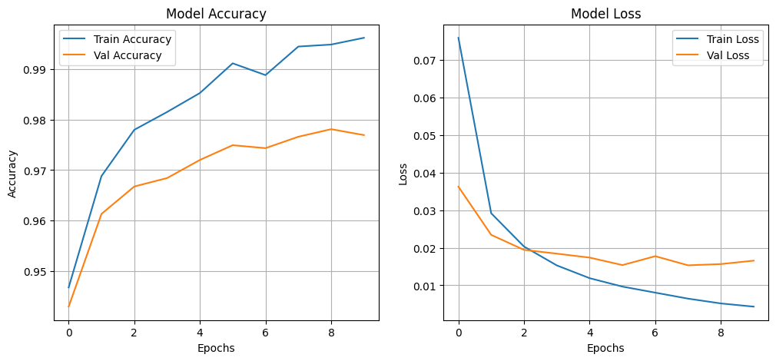
- SGD optimizer (momentum 0.9)
Train Acc: 0.96, Val Acc: 0.95  Test Acc: 0.957 | 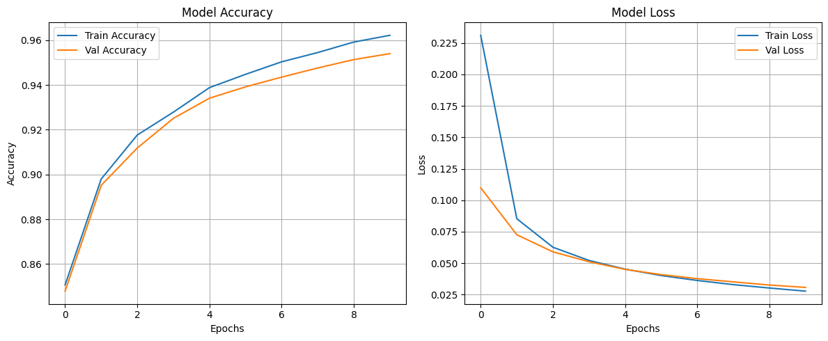

- RMSProp (alpha 0.99)

Train Acc: 1.00, Val Acc: 0.98  Test Acc: 0.978 | 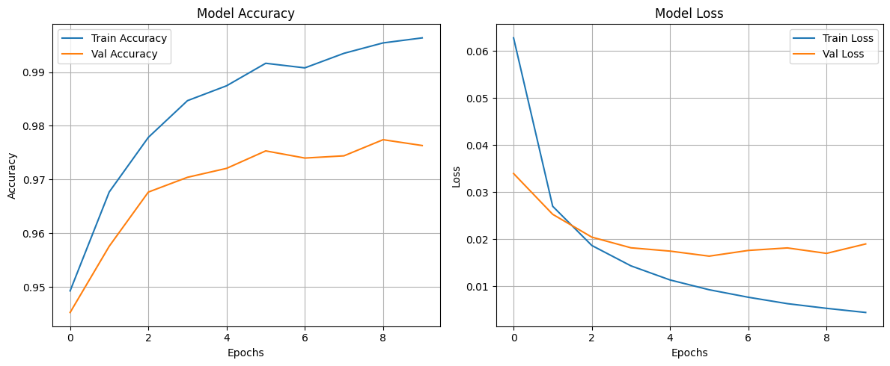

Both RMS Prop and Adam optimizers seem to suffer from overfitting as one can observe from their loss curves. They both have similar test accuracies. SGD has the highest test accuracy and the difference between training and validation accuracy is less pronounced. As one can see in the loss curve in (b), both losses are close to one another which suggests that it does not suffer from over fitting as much as the other optimizers.
Task 4: Observe and interpret the training and validation accuracy and loss curves.
- Observe the effect of changing the number of epochs on overfitting and underfitting.
Table 5
- With 10 Epochs (with Original Model)
Train Acc: 1.00, Val Acc: 0.98
Test Acc: 0.978

- With 20 Epochs
Train Acc: 1.00, Val Acc: 0.98  Test Acc: 0.980 | 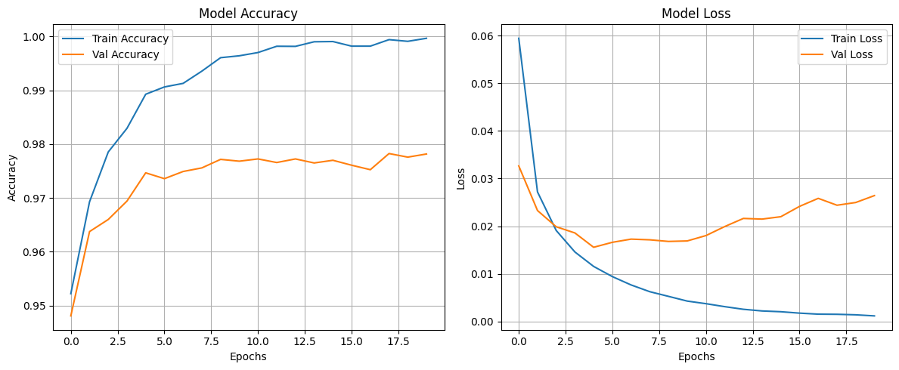
c) With 50 Epochs
Train Acc: 1.00, Val Acc: 0.98  Test Acc: 0.979 | 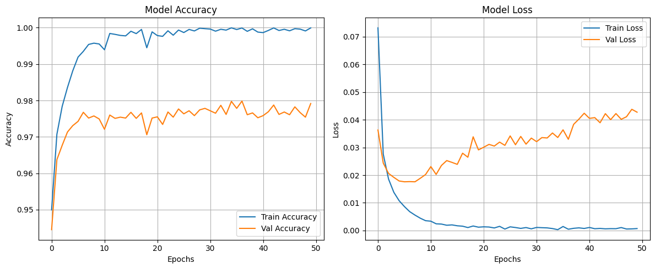

With more epochs, the model starts to overfit more. With 50 epoch these is a large margin between training loss and validation loss. Hence, the model that was trained with 50 epochs has lower accuracy than the model that was trained for only 20 epochs.
Early Stopping:
Early stopping was implemented with a patience of 3. After 11 epochs, the model’s training was stopped. By looking at the curve, it seems over fitting was happening as the training accuracy is 100% percent and the test accuracy is far lower at 97.6%
Train Acc: 1.00, Val Acc: 0.98, Val Loss: 0.0193
Test Acc: 0.976

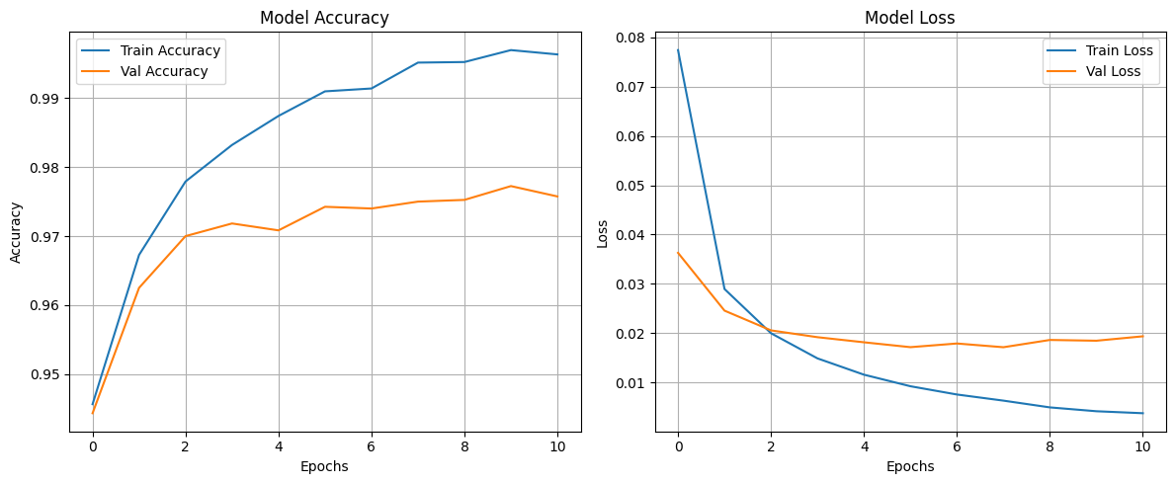

Improving the model
To create loss and accuracy curves similar to the ones shown in the Tutorial document, the following model parameters were set. Dropout and L2 Regularization was implemented to prevent overfitting and it is evident from the training and validation accuracy that overfitting was avoided largely.
Parameters:
Dropout of 20% after Activation Functions
Adam Optimizer with Learning Rate of 0.01
L2 Regularization with Weight Decay of 1e-9
Trained for 10 epochs
Performance Metrics:
Train Acc: 0.98, Val Acc: 0.97
Test Acc: 0.969

